Jennifer Stegina

20 September 2019

CIS 250

**Unit 4 Guided Practice 1**

The following questions come from the Task examples of Chapter 13 in your textbook.

After you are finished, please submit a Microsoft Word file that contains screenshots of the SQL Queries, the output, and put a comment line in the query with your last name. Your document should be named **U4_GuidedPractice1_Lastname.docx**.

(13-3) Question 1:

Join the *fruits* table and the *colors* table with an inner join. Match the *f_num* column of the *fruits* table with the *c_num* column of the *colors* table. Combine a row of the *fruits* table with a row of the *colors* table when the values in these matching columns are equal. Because of the data in the beginning tables, this creates a one-to-one relationship between the two beginning tables.

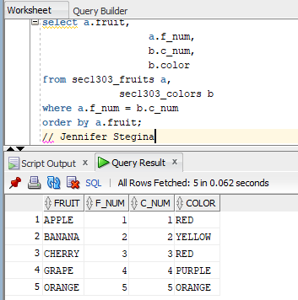

(13-4) Question 2:

Join the *fruits* table and the *colors* table with an inner join. Use the same join condition as the previous section. The data here show a many-to-one relationship between the tables.

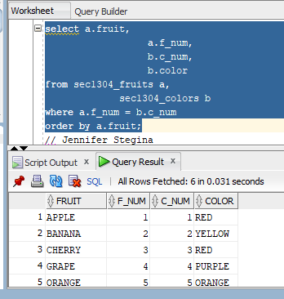

(13-5) Question 3:

Join the *fruits* table and the *colors* table with an inner join. Use the same join condition as in the previous sections.

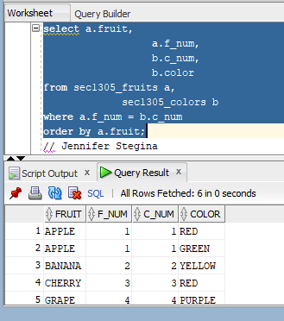

(13-6) Question 4:

Join the *fruits* table and the *colors* table with an inner join. Use the same join condition as in the previous sections.

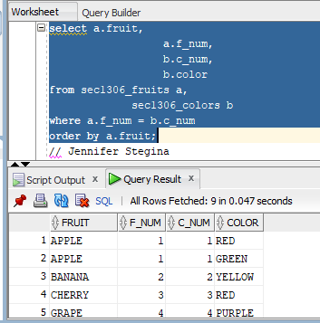

(13-7) Question 5:

Join the *fruits* table and the *colors* table with an inner join with the join condition used in the previous sections. The data here show that rows in beginning tables may not appear at all in the result table.

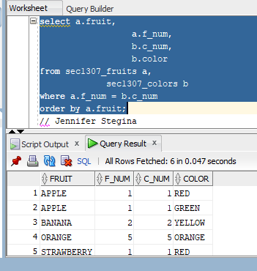

(13-8) Question 6:

Join the *fruits* table and the *colors* table with an inner join using the join condition from the previous sections. Note that there is no brown kiwi in the result table.

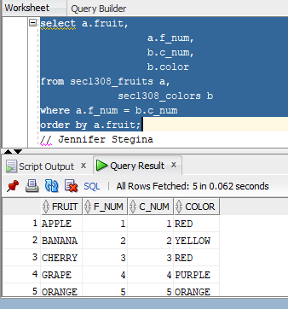

(13-9) Question 7:

Show the five ways of writing the SQL for the inner join used in the previous sections.

